T

TIBCO BusinessEvents: Views

Product Suite | TIBCO BusinessEvents
Product | Views
Product Version | 5.1
Initial Author | Mark Wiley

Copyright Notice
COPYRIGHT© 2011 TIBCO Software Inc. This document is unpublished and the foregoing notice is affixed to protect TIBCO Software Inc. in the event of inadvertent publication. All rights reserved. No part of this document may be reproduced in any form, including photocopying or transmission electronically to any computer, without prior written consent of TIBCO Software Inc. The information contained in this document is confidential and proprietary to TIBCO Software Inc. and may not be used or disclosed except as expressly authorized in writing by TIBCO Software Inc. Copyright protection includes material generated from our software programs displayed on the screen, such as icons, screen displays, and the like.
Trademarks
Technologies described herein are either covered by existing patents or patent applications are in progress. All brand and product names are trademarks or registered trademarks of their respective holders and are hereby acknowledged.
Confidentiality
The information in this document is subject to change without notice. This document contains information that is confidential and proprietary to TIBCO Software Inc. and may not be copied, published, or disclosed to others, or used for any purposes other than review, without written authorization of an officer of TIBCO Software Inc. Submission of this document does not represent a commitment to implement any portion of this specification in the products of the submitters.
Content Warranty
The information in this document is subject to change without notice. THIS DOCUMENT IS PROVIDED "AS IS" AND TIBCO MAKES NO WARRANTY, EXPRESS, IMPLIED, OR STATUTORY, INCLUDING BUT NOT LIMITED TO ALL WARRANTIES OF MERCHANTABILITY OR FITNESS FOR A PARTICULAR PURPOSE. TIBCO Software Inc. shall not be liable for errors contained herein or for incidental or consequential damages in connection with the furnishing, performance or use of this material.
For more information, please contact:
TIBCO Software Inc.
3303 Hillview Avenue
Palo Alto, CA 94304
USA
Table of Contents
TIBCO BusinessEvents: Views 1
1 Change Log 4
1.1 Related Documents 4
2 Introduction 5
2.1 Main Objective 5
2.2 Intended Usage 5
2.3 Scope 5
2.4 Audience 5
3 Acronyms and Vocabulary 6
4 General Requirements 6
4.1 Packaging 6
5 Non-Functional Requirements 6
5.1 Web browser support 6
5.2 Server support 6
5.3 Performance 6
6 Functional Requirements 7
6.1 User Interactions 7
6.1.1 Login 7
6.1.2 Component Selection 7
6.1.3 Component Display 8
7 System Design 8
7.1 Portlet Initialization 8
7.1.1 Configuration 9
7.2 Portlet Communication 9
7.2.1 Startup 9
7.2.2 Updates 10
8 Technology Overview 11
9 Screen Shots 11
9.1 User Login 11
9.2 Component Selection 12
9.3 Component Display 13

Change Log
.
Date | Version | Name | Description
01/17/2012 | 1.0 | Mark Wiley | Initial doc

Related Documents
Document Title | Revision Number | Author

Introduction

Main Objective
This document explains the technical requirements of bringing Business Events Views components to a portal environment and provides an in-depth look at the user’s experience.

Intended Usage
The intent of this document is to present the BE Views portal solution, highlight technical challenges, and to explore the potential short-comings of our solution.

Scope
The scope of this document is limited to portal support of BE Views components, the technologies needed to implement it, and the end user experience.

Audience
The document is intended for User Interaction Designers, Developers, Architects, QA and Managers.

Acronyms and Vocabulary
- Portal – For our purposes, a portal (or more specifically a web portal) is a web site that aggregates information from potentially many different data sources and displays said information together in a single portal page.
- Portlet – A portal component, a portlet provides and displays information from a particular data source on a portal page.
- Portal server – Provides the services necessary to display a portal. Additional services provided by a portal server may include security, configuration, and personalization.
- Portlet provider – Service that provides portlet specifications and resources needed to be shown in a portal.
- Google Gadgets – Google’s version of portlets, only gadgets use no back-end server logic.
- Java Portlet Specifications (JSR168, JSR286) – Specifies the interfaces, objects, and protocols that are required for both portal and portlet development.

General Requirements

Packaging
The packaging will be within the current BE Views add-on

Non-Functional Requirements

Web browser support
All modern browsers and platforms which support Flash Player 10.X will be supported. The support for 64-bit platforms will be beta, since Adobe has only recently launched a beta version of the 64-bit flash player

Server support
Both BE Views dashboard and portal hosting services are required for BE Views portlets. Portal server types supported will include GoogleGadgets, JSR168, and JSR268 (GoogleGadgets will be emphasized).

Performance
Performance of portlets should be on par with the components contained in the BE Views dashboard.

Functional Requirements

Portlet support for BE Views components enables portal users to include individual BE Views components (tables, charts, etc.) in their portal pages as a portlet. Multiple portlets may be added to a portal to enable the display of many BE Views components.

User Interactions

Login
Performing the login process is required in only one of the potentially many BE Views portlets being displayed in a particular portal. Before logging in, all BE Views portlets will be in the Login – User Authentication state, prompting the user for authentication. Successful user authentication will progress all BE Views portlets to the Login - Role Selection state, and successful role selection will progress all BE Views portlets to the Component Selection state. In other words, the login process is synchronized among all BE Views portlets in the portal. Subsequent user actions (i.e. selecting a component to display) will only affect the portlet where that action is performed.

User Authentication

Triggering Action | Initial state after portlet has loaded
User Feedback | Username and Password form is displayed
Success | User presented with a “login successful” message and continues on to Role Selection if multiple roles exist for that user.
Failure | User presented with a “login failed” message and is prompted to re-enter user credentials

Role Selection

Triggering Action | Successful user authentication
User Feedback | A drop-down menu is displayed, listing the available roles. If only one role exists, Success is assumed with that role.
Success | Progress to the Component Selection state
Failure | A failure message is show describing what went wrong. If selection of a particular role failed, that row is removed from the selection drop-down (maybe)

Component Selection

Triggering Action | A user has successfully authenticated and selected a role.
User Feedback | A list of available BE Views components is listed.
Success | Upon user selection of a component, the user progresses to the Component Display state
Failure | In place message showing what went wrong

Component Display

Expanding Type Row/Data Row

Triggering Action | A BE Views component was successfully chosen during the Component Selection state
User Feedback | The selected component is displayed in the portlet
Success | The component is displayed and updated as expected
Failure | An error message is shown and the component is partially grayed indicating that it is not actively receiving updates

System Design

A portal server is required for use. Given a portal server, users can add the appropriate BE Views portlet (GoogleGadget or JSR version) to their portal page.

The UI-server interactions will be XML over HTTP similar to how the dashboard currently communicates with the dashboard agent. Each portlet instance will run on its own.

Portlet Initialization
BE Views will support portlets in a variety of portal environments. Portlet specification files are used to define portlet properties and content.

Google Gadgets
<?xml version="1.0" encoding="UTF-8" ?>
<Module>
<ModulePrefs title="Business Events Views">
<Require feature="flash" />
</ModulePrefs>
<Content type="html">
<![CDATA[
<div id="flashcontainer" style="text-align: center;"></div>
<script type="text/javascript">
function showSwf(){
gadgets.flash.embedFlash(
"http://mwiley-dt.na.tibco.com/test/portlet/BEVPortlet.swf",
"flashcontainer", {
swf_version: 6,
id: "flashid",
width: 320,
height: 250
}
)
}
gadgets.util.registerOnLoadHandler(showSwf);
</script>
]]>
</Content>
</Module>

JSR (168 and 268)
TODO

Configuration
BE Views portlets require configuration much like the BE Views dashboard. A clientconfig.xml file is hosted by the portlet provider and is fetched by the BE Views portlet upon loading. The configuration file is used to set configuration parameters for the dashboard server location, data fetch and streaming ports, as well settings to control the number of reconnect attempts on streaming server disconnect and streaming server update interval.

Portlet Communication

Startup

Login

Request | - command = signin  - username = username of the user  - rawpassword = the password associated with the given username
Success | <response>  <state>OK</state>  <content>#USER-TOKEN#</content>  </response>
Failure | Standard Failure Response

Set Role

Request | - command = getroles  - stoken = the user token returned on successful login
Success | <response>  <state>OK</state>  <content>  <roles>  <role name=”USER_1” />  <role name=”USER_2” />  </roles>  </content>  </response>
Failure | Standard Failure Response

Validate Role

Request | - command = validaterole  - role = the role to validate  - stoken = the user token returned on successful login
Success | <response>  <state>OK</state>  <content>#ROLE-NAME# is valid</content>  </response>
Failure | Standard Failure Response

Get Component List

Request | - command = searchcomps  - criteria = a string to used to guide the component search  - stoken = the user token returned on successful login
Success | <response>  <state>OK</state>  <content></content>  </response>
Failure | Standard Failure Response

Get Component Config

Request | - command = getcomponentconfig  - componentid = the ID of the BE Views component  - stoken = the user token returned on successful login
Success | <response>  <state>OK</state>  <content>  <chartmodel componentid=”#COMPONENT-ID#”  componentname=”#COMPONENT-NAME#”  componenttype=”#COMPONENT-TYPE#”>  …  </chartmodel>  </content>  </response>
Failure | Standard Failure Response

Get Component Data

Request | - command = getcomponentdata  - componentid = the ID of the BE Views component  - stoken = the user token returned on successful login
Success | <response>  <state>OK</state>  <content>  <visualizationdata componentid=”#COMPONENT-ID#”>  …  </chartmodel>  </content>  </response>
Failure | Standard Failure Response

Updates
Updates are done in one of two ways depending on portal deployment. Portlets can either update via pushed updates from the server over a streaming connection or by polling the server with get data requests as detailed in the previous section. For server-pushed updates, a portlet must subscribe to updates for the component it’s displaying. TODO: determine socket update approach and sharing of update data amongst portlets.

Subscribe

Request | - command = subscribe  - name = dashboard  - componenname = the name of the BE Views component  - stoken = the user token returned on successful login
Success | <response>  <state>OK</state>  <content />  </response>
Failure | Standard Failure Response

Technology Overview
The UI will be developed using Flex, the current dashboard framework, Google Gadgets, and potentially Java’s JSR 169 and 268 portlet specification. The current dashboard framework will drive portlet configuration and component display.

The backend APIs will be developed using the in-house dashboard agent code base.

Screen Shots
Note that the following screen shots are mock-ups, created using a graphics editing tool. They are meant only to serve as a means for conveying possible user experience and do not reflect the actual state of BE Views portlets.

User Login
When users log in, all portlets displayed on the portal will start by displaying the user login state. Recall that the login process is a coordinated process among all portlets; in other words, what’s done in one portlet during login will be reflected in all other portlets.
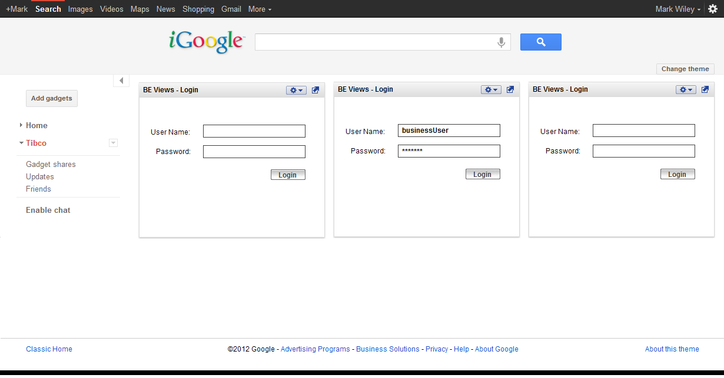

Component Selection
Component selection lists all possible components that the user is able to display in a list. Once the component has been chosen, the user will proceed to the Component Display state.

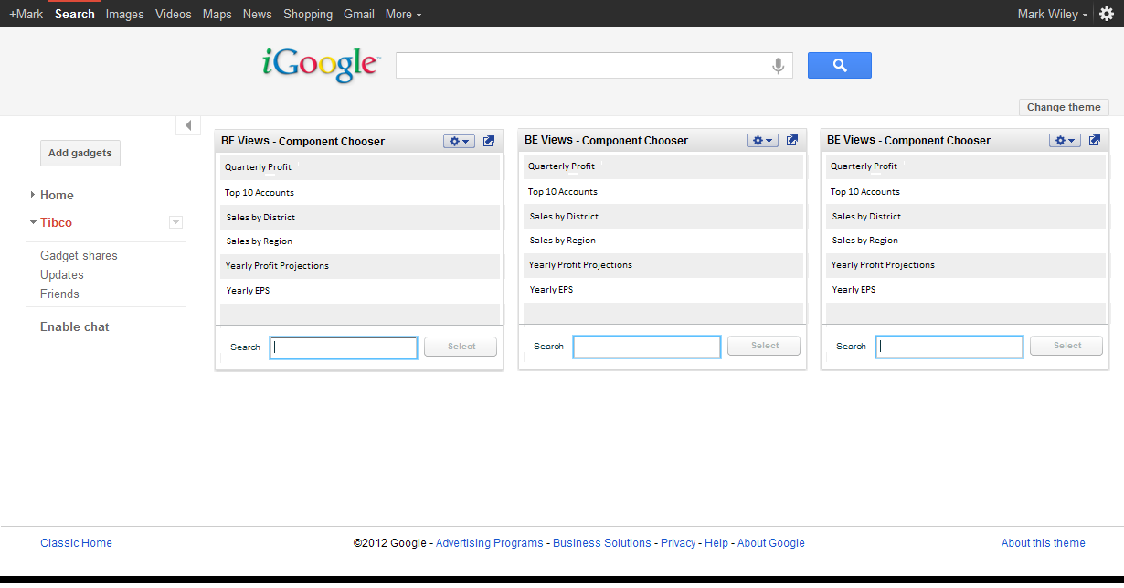

Component Display

